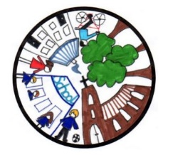
Walsham le Willows Neighbourhood Plan Report written 07.10.21

UPDATE FOR PARISH COUNCIL MEETING: 13th October 2021

Work to date (in the last month)

Work ahead (over the next month or so)

UPCOMING CONSULTATION EVENTS

Rachel Leggett, Project Manager, 07947 615335
Email address for the project: walshamlewillowsplan@gmail.com
Neighbourhood Plan website: www.walsham-le-willows.org

